Practical 6
1. Aim
To create and deploy a RESTful API using AWS Lambda and Amazon API Gateway to perform basic CRUD (Create, Read, Update, and Delete) operations.
2. Software and Tools Required
- Amazon Web Services (AWS) account
- AWS Lambda
- Amazon API Gateway
- Python 3.x runtime
- Web browser or API testing tool such as Postman
3. Theory
AWS Lambda is a serverless computing service that allows users to execute code without managing servers. It runs a function in response to events or requests.
Amazon API Gateway is a service used to create, publish, and manage APIs. It receives HTTP requests and forwards them to the appropriate backend, such as an AWS Lambda function.
A RESTful API follows REST principles and uses HTTP methods to perform operations on resources.
Common HTTP methods are:
- GET: Retrieve data.
- POST: Create a new resource.
- PUT: Update an existing resource.
- DELETE: Delete a resource.
In this practical, API Gateway acts as the entry point for HTTP requests, while AWS Lambda processes the requests and returns responses in JSON format.
4. Procedure
Step 1: Create an AWS Lambda Function
- Log in to the AWS Management Console.
- Open the AWS Lambda service.

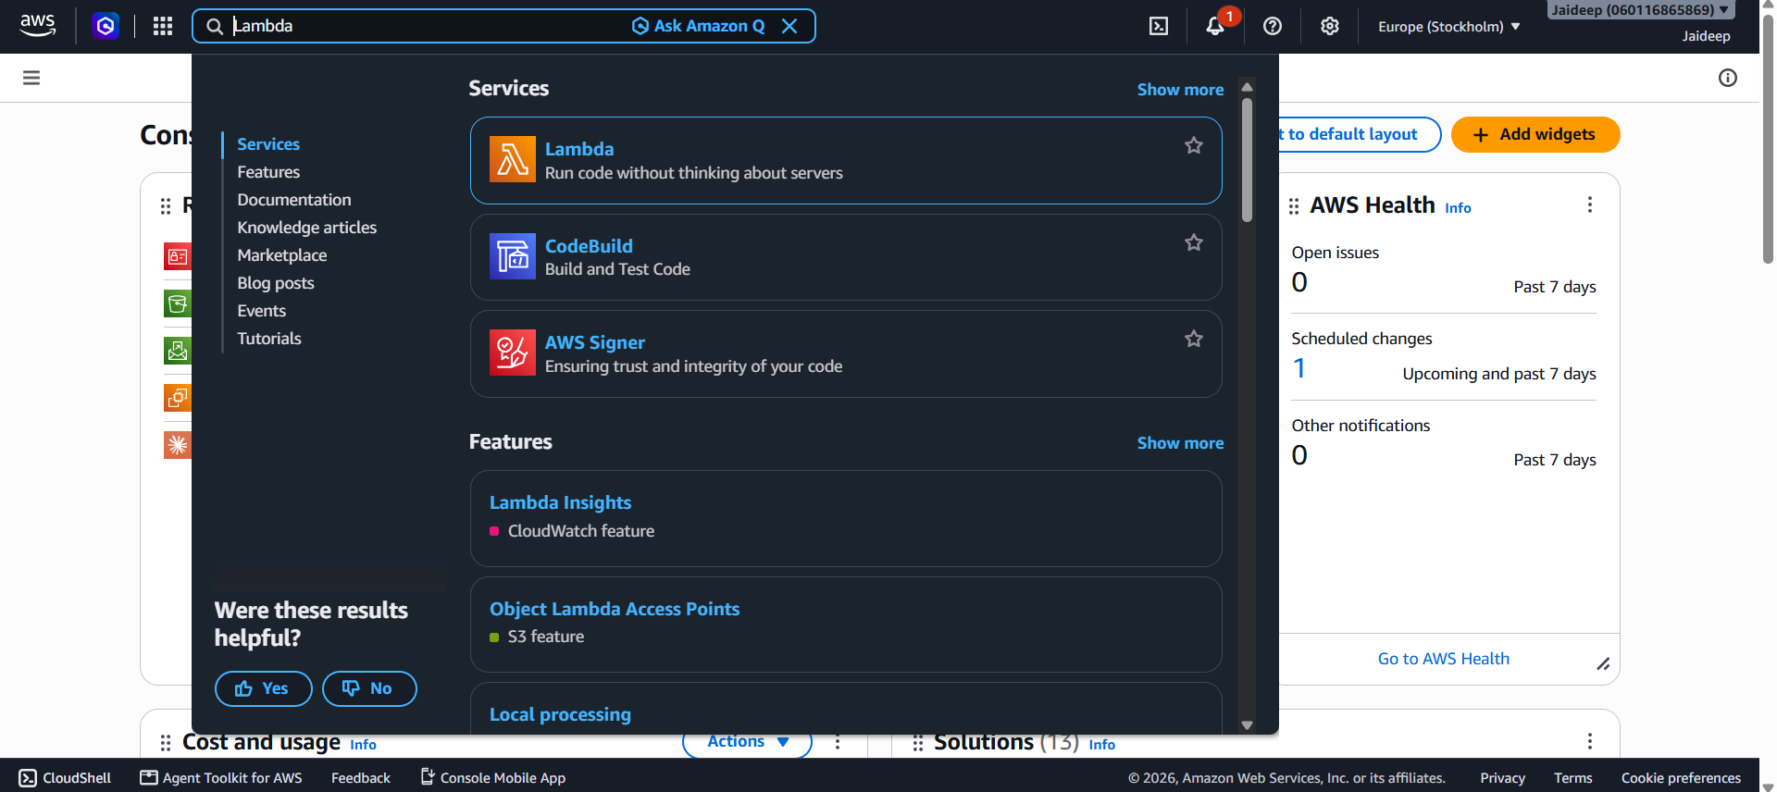
- Click Create function.
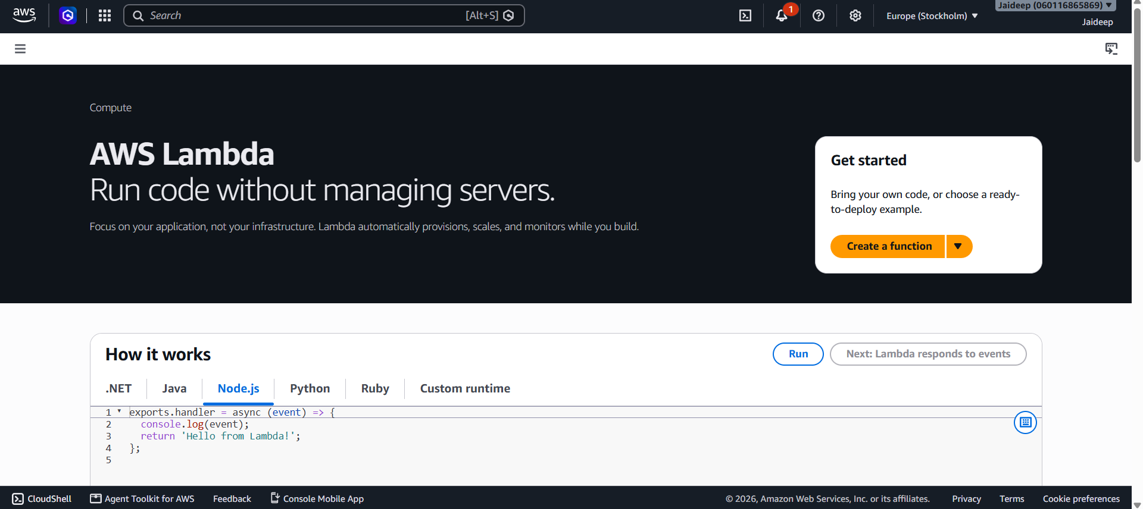
- Select Author from scratch.
- Enter the function name as StudentAPI.

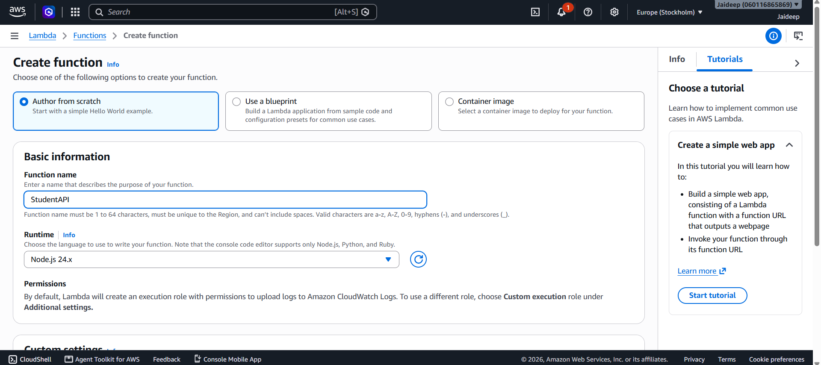
- Select Python as the runtime.
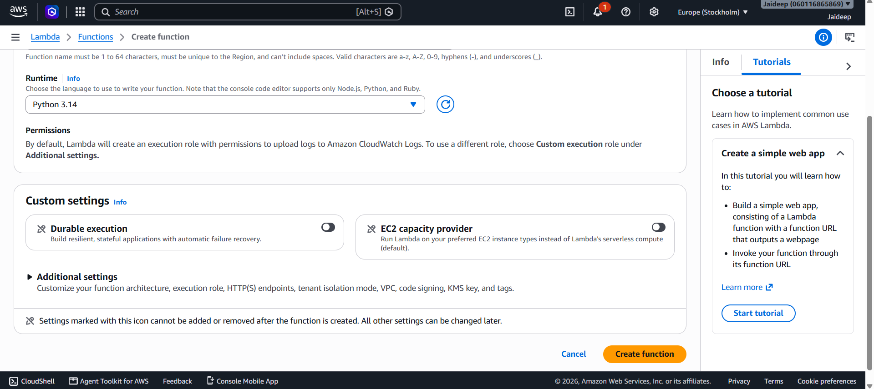
- Create the function.
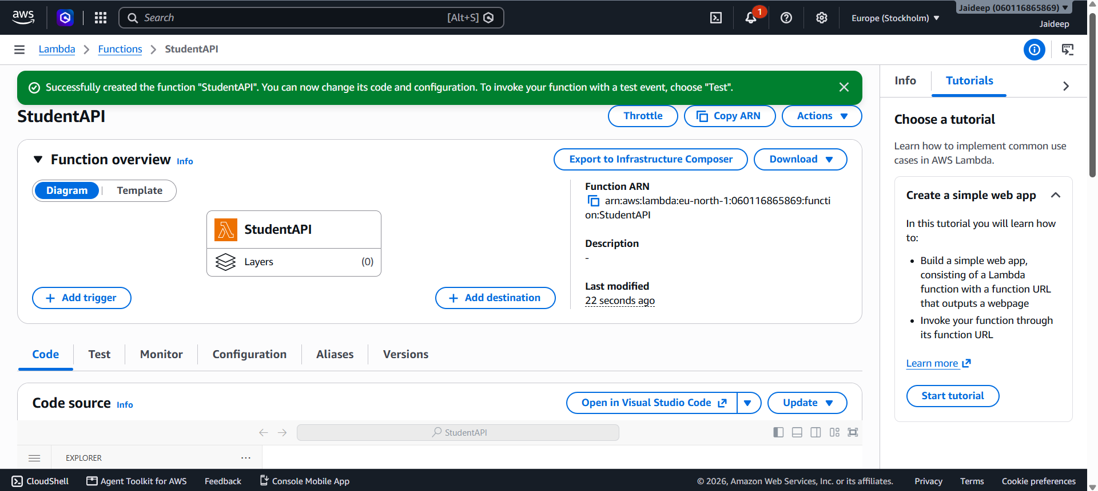
Step 2: Write the Lambda Function
Replace the default code with the following Python code:
import json

# Sample student records
students = {
"1": {"id": "1", "name": "Jaideep"},
"2": {"id": "2", "name": "Aakriti"},
"3": {"id": "3", "name": "Aananya"}
}

def lambda_handler(event, context):
try:
# Get HTTP method and path parameters from API Gateway
method = event.get("httpMethod", "GET")
path_parameters = event.get("pathParameters") or {}
student_id = path_parameters.get("id")

# GET: Retrieve all students or one student
if method == "GET":

if student_id:
student = students.get(student_id)

if student is None:
return response(404, {
"message": "Student not found"
})

return response(200, student)

return response(200, list(students.values()))

# POST: Create a new student
elif method == "POST":
data = get_request_body(event)

if not data.get("id") or not data.get("name"):
return response(400, {
"message": "Student ID and name are required"
})

new_id = str(data["id"])

if new_id in students:
return response(409, {
"message": "Student ID already exists"
})

student = {
"id": new_id,
"name": data["name"]
}

students[new_id] = student

return response(201, student)

# PUT: Update an existing student
elif method == "PUT":
if not student_id:
return response(400, {
"message": "Student ID is required in the URL"
})

if student_id not in students:
return response(404, {
"message": "Student not found"
})

data = get_request_body(event)

if not data.get("name"):
return response(400, {
"message": "Student name is required"
})

students[student_id]["name"] = data["name"]

return response(200, students[student_id])

# DELETE: Remove a student
elif method == "DELETE":
if not student_id:
return response(400, {
"message": "Student ID is required in the URL"
})

if student_id not in students:
return response(404, {
"message": "Student not found"
})

deleted_student = students.pop(student_id)

return response(200, {
"message": "Student deleted successfully",
"student": deleted_student
})

# Unsupported HTTP method
else:
return response(405, {
"message": "Method not allowed"
})

except (json.JSONDecodeError, ValueError):
return response(400, {
"message": "Invalid JSON request body"
})

except Exception:
return response(500, {
"message": "Internal server error"
})

def get_request_body(event):
body = event.get("body")

if not body:
return {}

if isinstance(body, dict):
return body

return json.loads(body)

def response(status_code, body):
return {
"statusCode": status_code,
"headers": {
"Content-Type": "application/json"
},
"body": json.dumps(body)

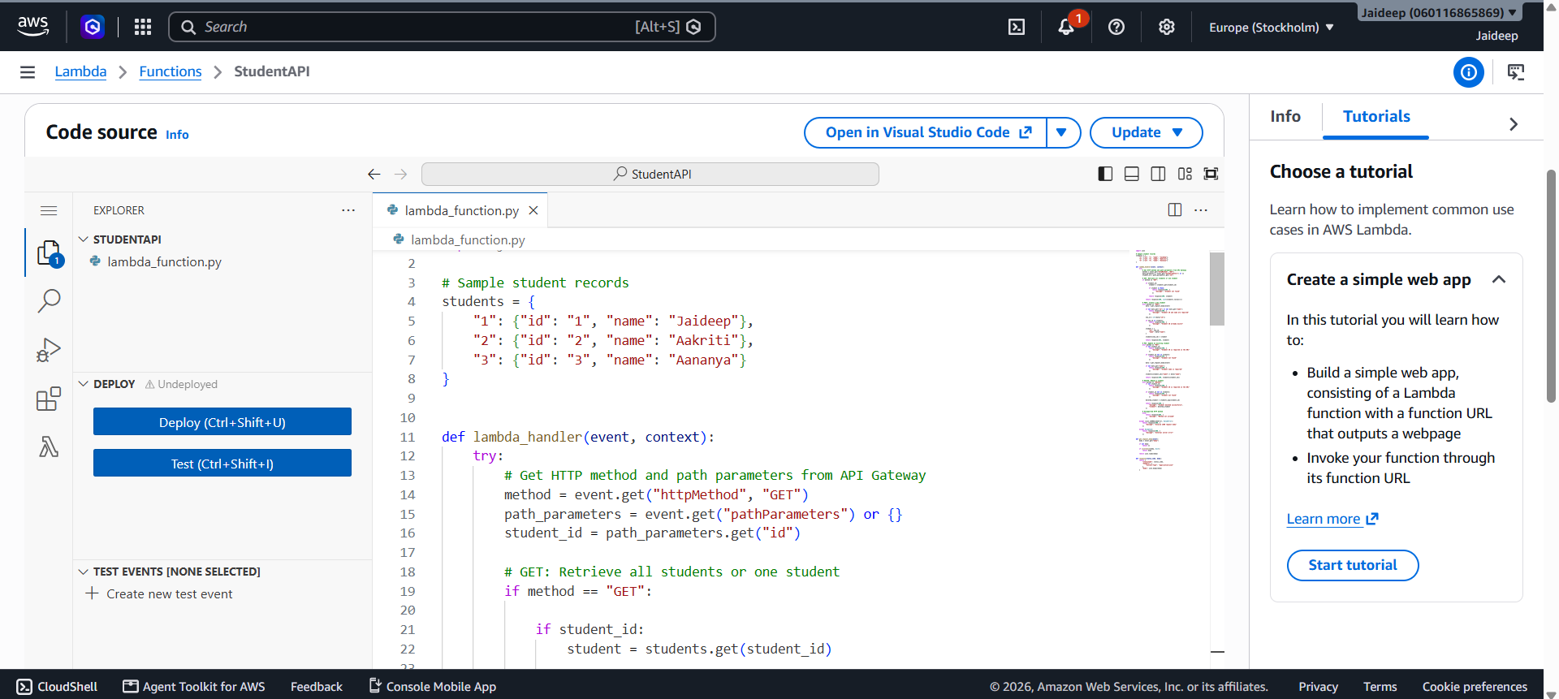
Click Deploy to save the function.
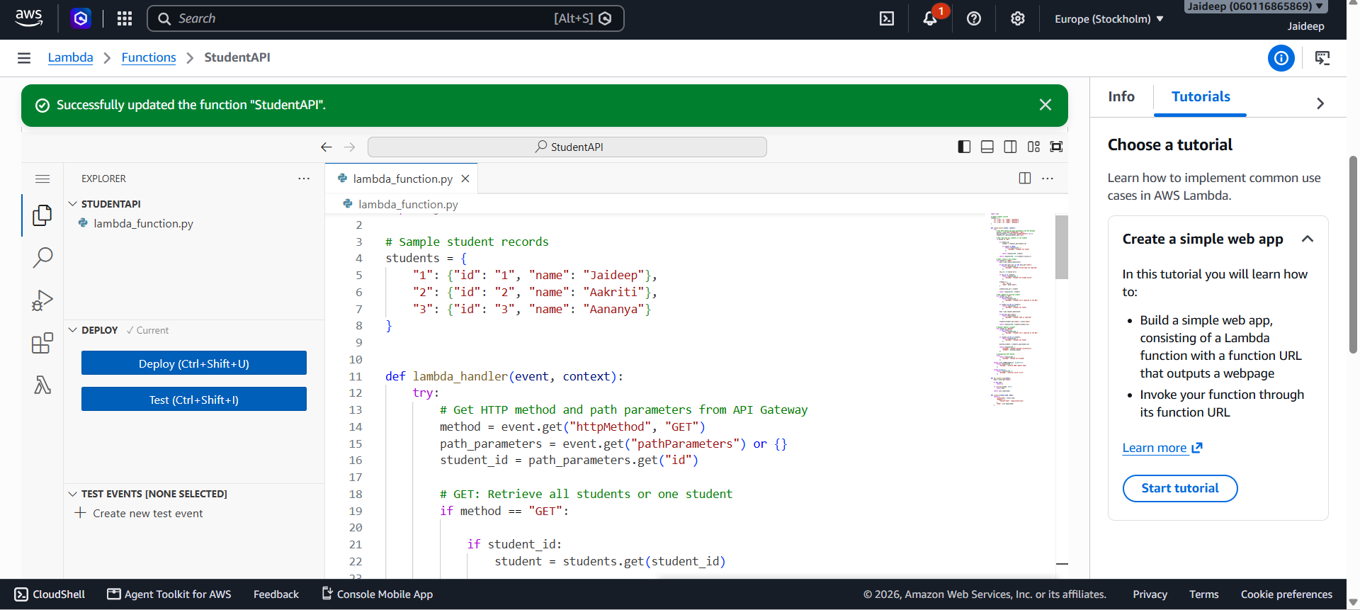
Step 3: Test the Lambda Function
- Open the Lambda function's Test tab.

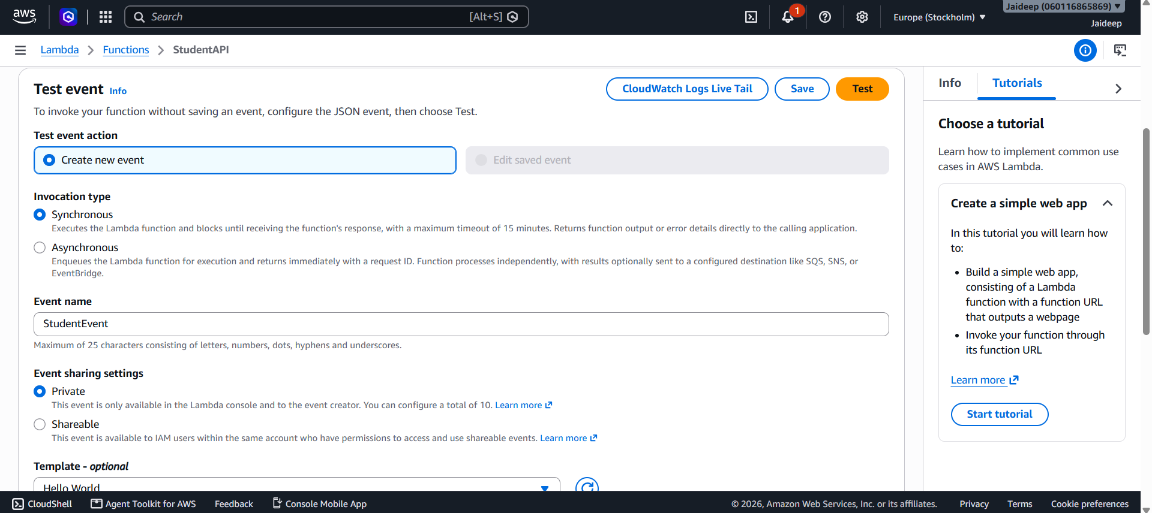
- Create a test event with the following JSON:
{
"httpMethod": "GET",
"pathParameters": null,
"body": null
}

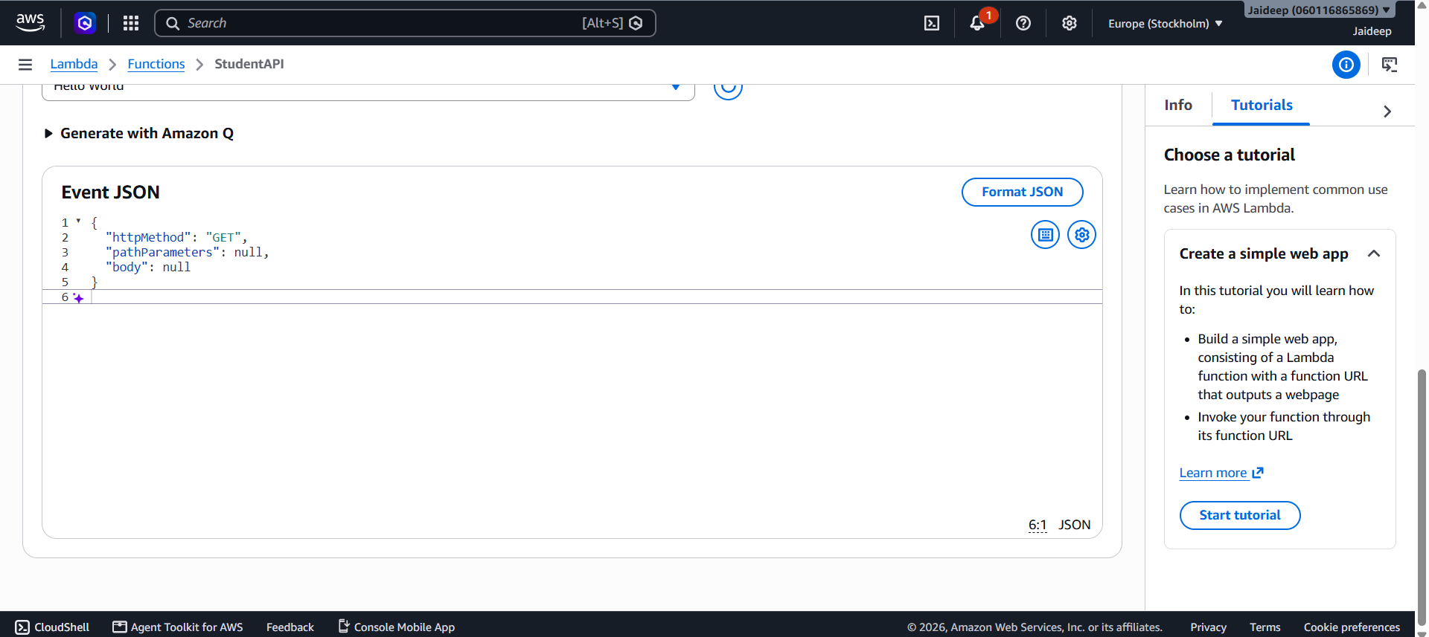
- Run the test.

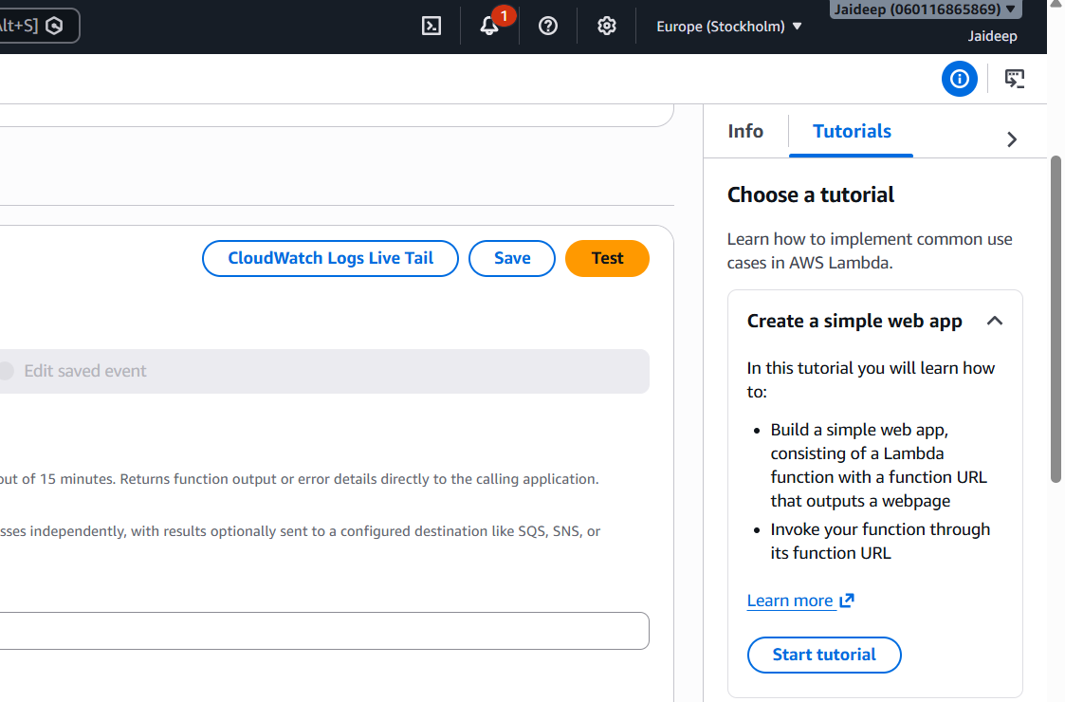
- Verify that the function returns a successful response containing the student records.
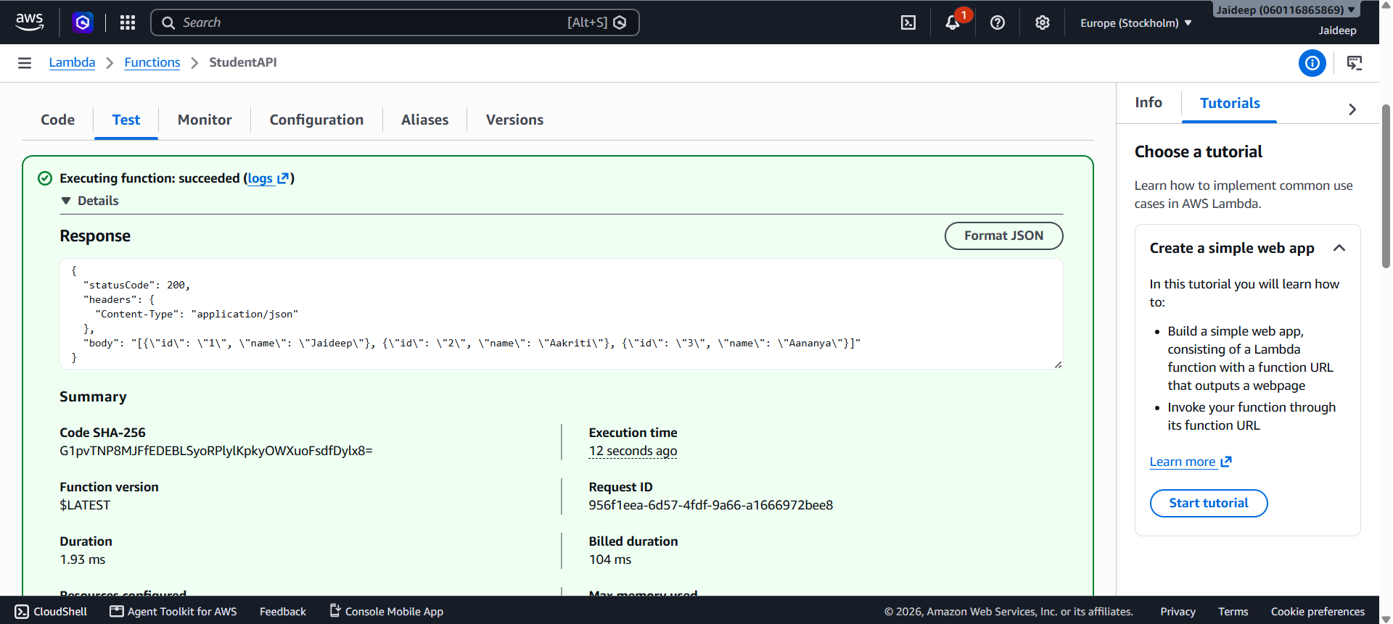
Step 4: Create an API Using API Gateway
- Open the Amazon API Gateway service
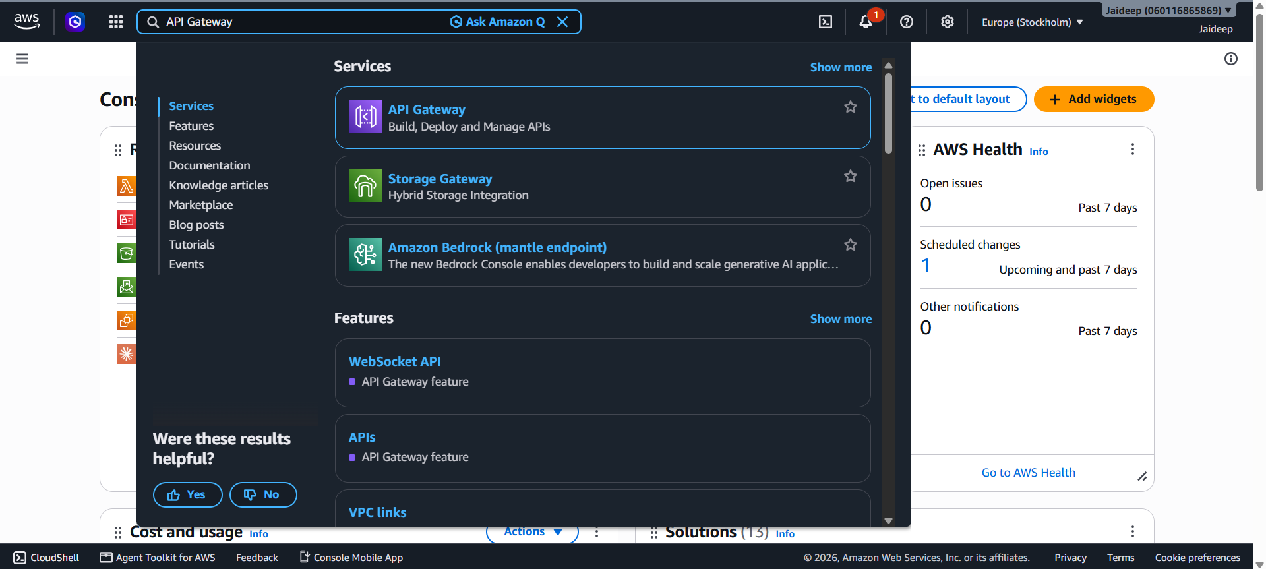
- Choose Create API
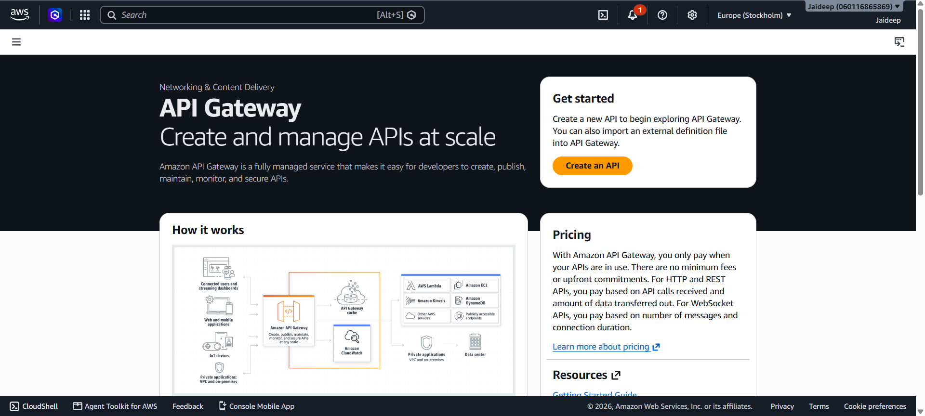
- Select REST API and click Build
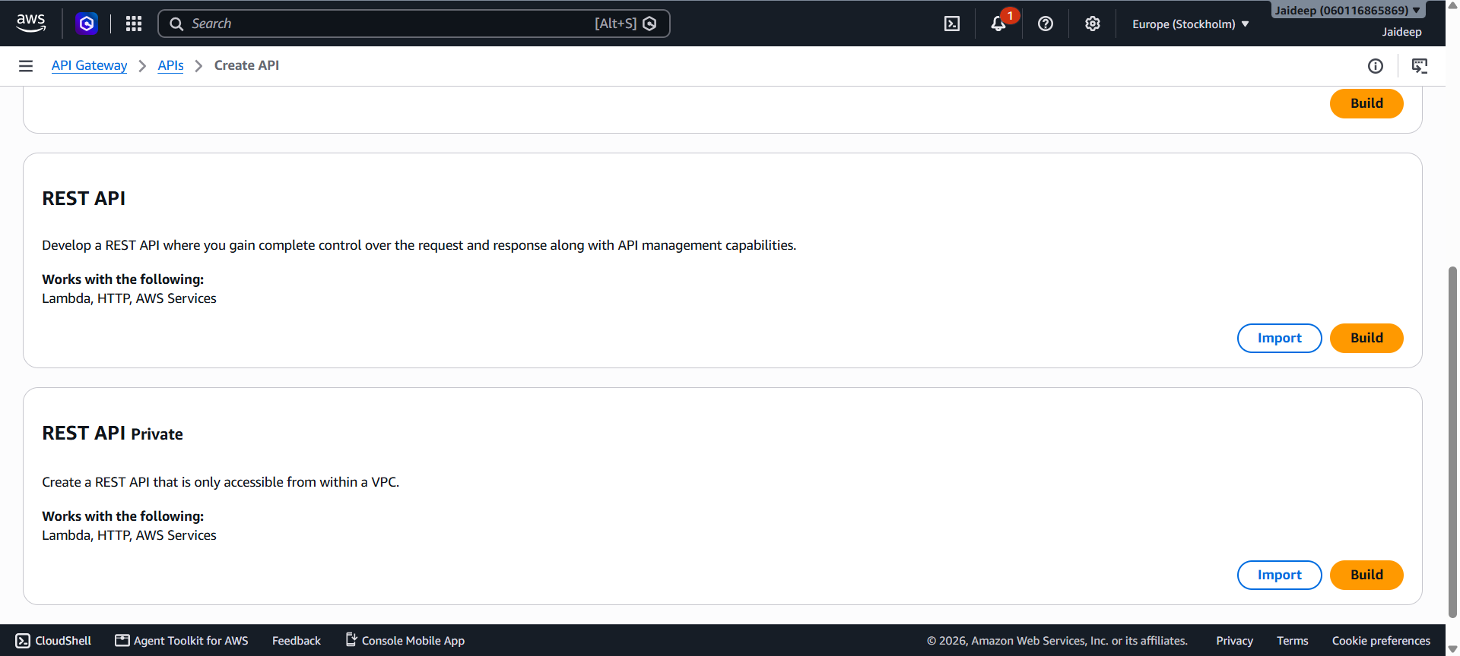
- Enter an API name, such as StudentRESTAPI.
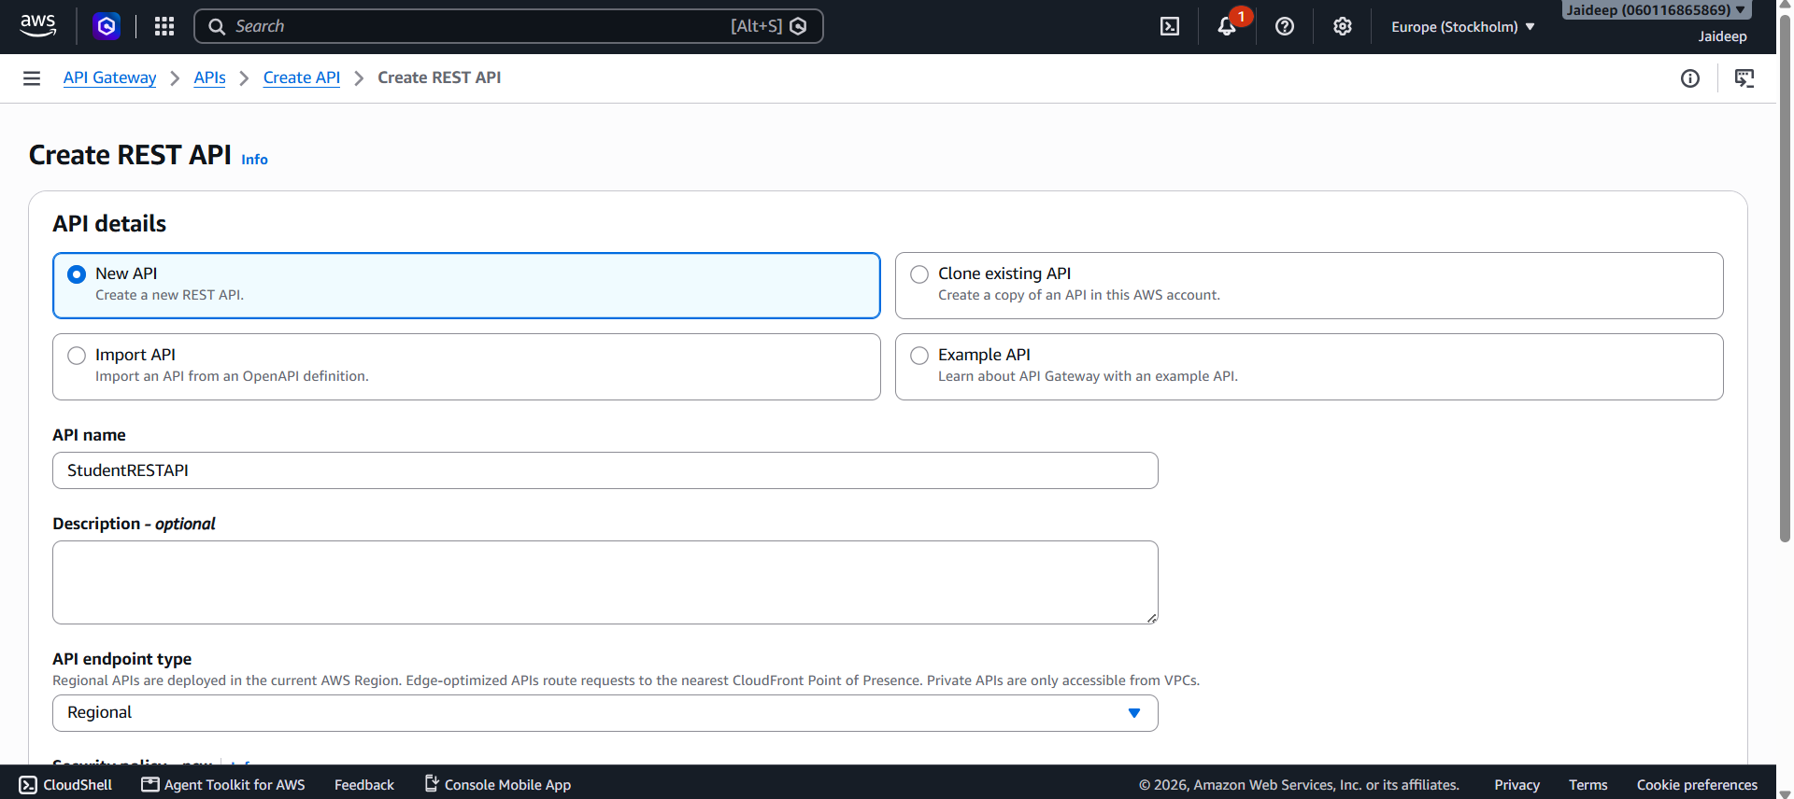
- Create the API.
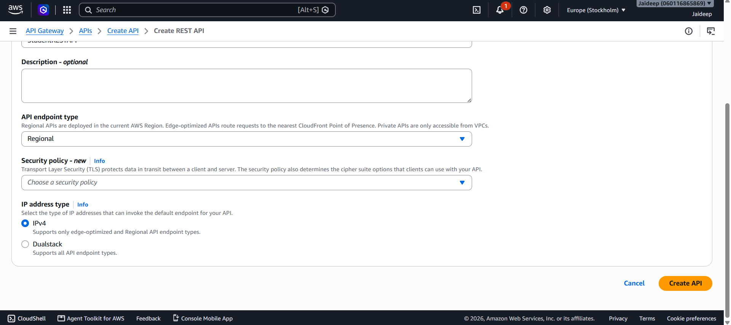
Step 5: Create API Resources and Methods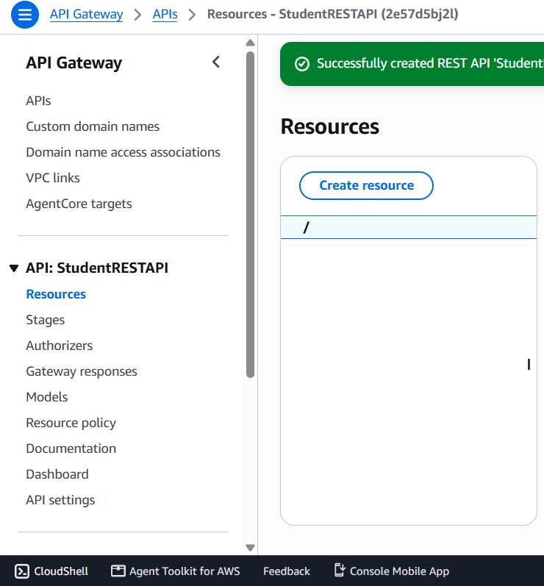
Create the following resources by clicking Create Resource:
Resource | HTTP Method | Purpose
/students  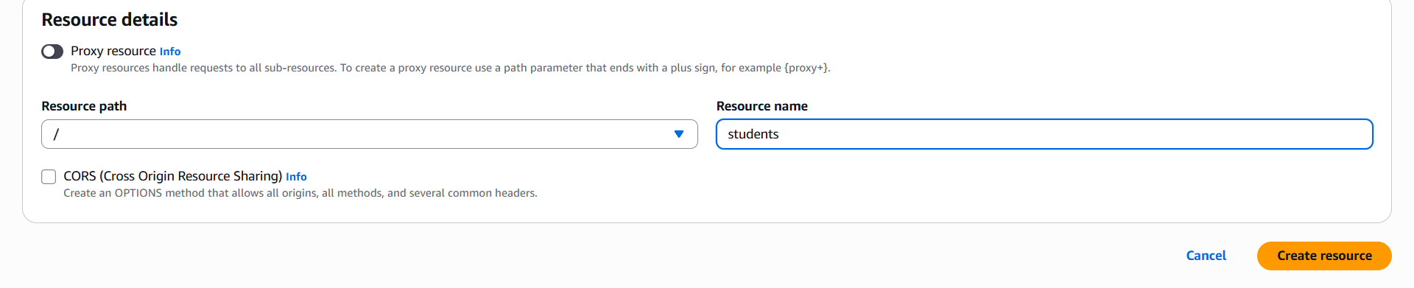 | GET | Retrieve all students
/students | POST | Add a student
/students/{id}  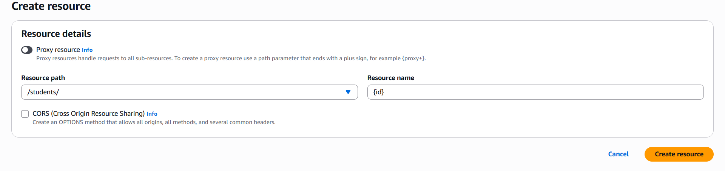 | GET | Retrieve a student by ID
/students/{id} | PUT | Update a student
/students/{id} | DELETE | Delete a student

Make sure the final Resources tree looks like this:
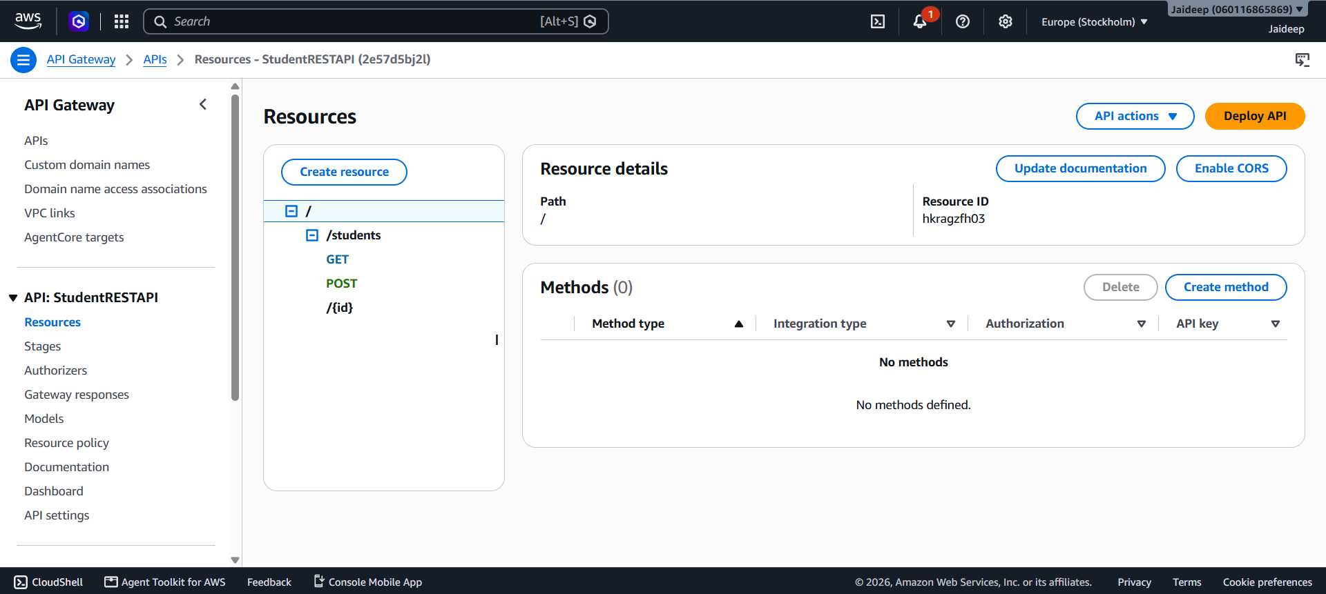
Create Methods for API:
- Creating methods for /students resource:
On the same previous page, select the /students resource in the Resources tree.

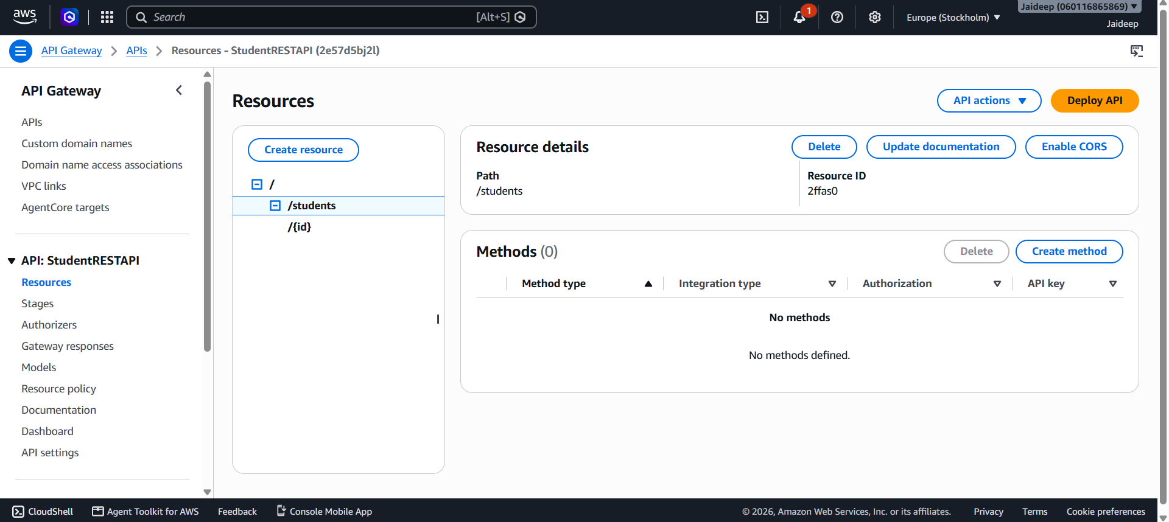
Click on Create method.
- GET METHOD:
- Under Method type, open the dropdown and select GET.
- Under Integration type, select Lambda function — not HTTP.
- Enable Lambda proxy integration.
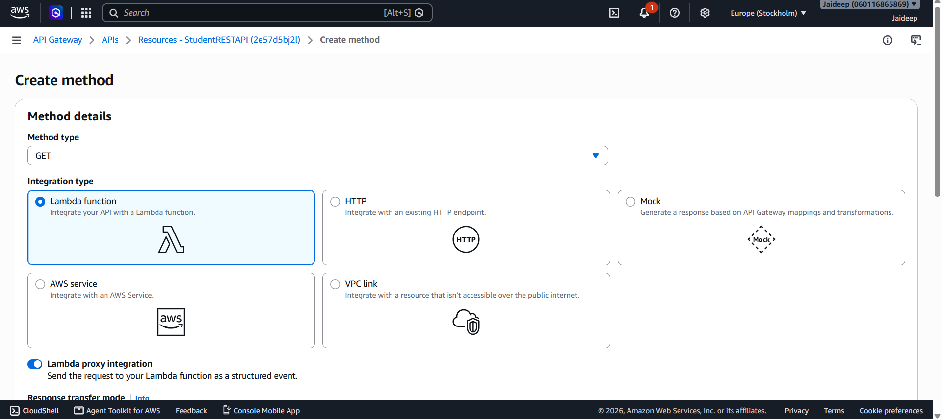
- Select the AWS Region where your Lambda function exists.
- In the Lambda function field, enter or select StudentAPI.Leave the integration timeout at its default.
- Click Create method.

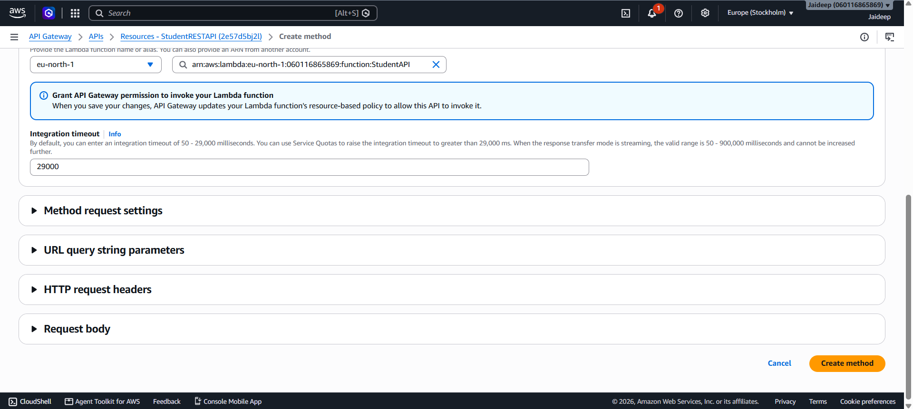

- POST METHOD:
- Select the /students resource in the Resources tree.
- Click Create method.
- Select POST as the method type.
- Select Lambda function as the integration type.
- Enable Lambda proxy integration.
- Choose the same StudentAPI function.
- Click Create method

- Creating methods for /students/{id} resource:
Select /students/{id} as the resource from the Resources tree.
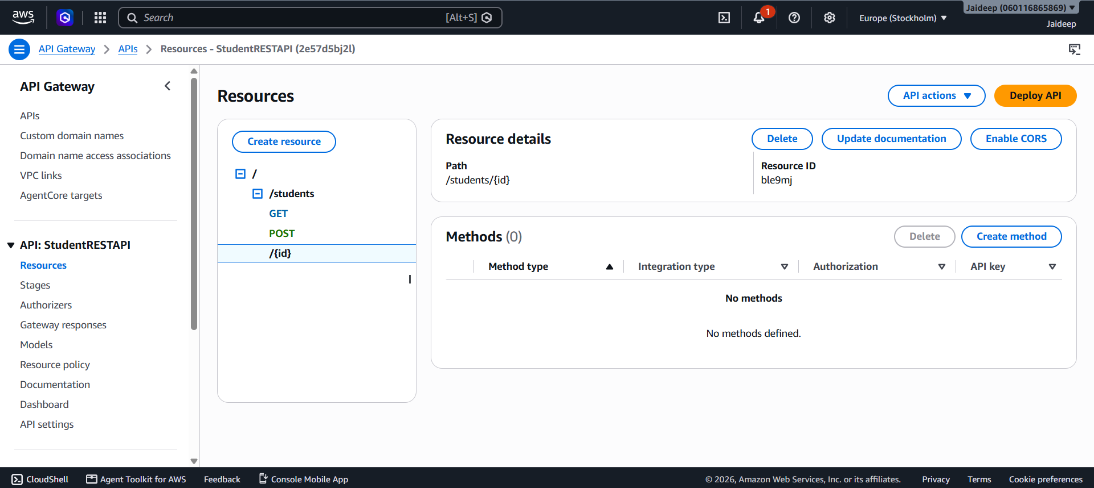
Create each of these methods separately:
Method | Integration type | Lambda function
GET | Lambda function | StudentAPI
PUT | Lambda function | StudentAPI
DELETE | Lambda function | StudentAPI

For every method:
- Choose the HTTP method.
- Select Lambda function.
- Enable Lambda proxy integration.
- Select StudentAPI.
- Click Create method.

Step 6: Deploy the API
- Select Deploy API
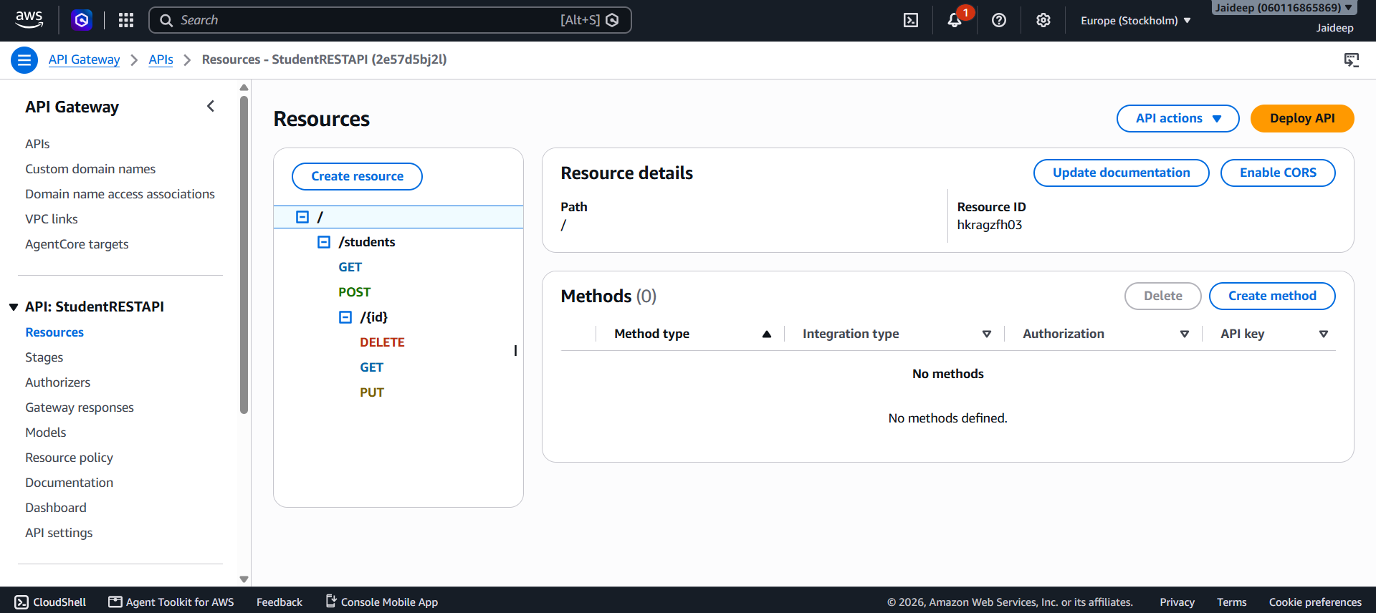
- Create a new stage named dev.
- Deploy the API.

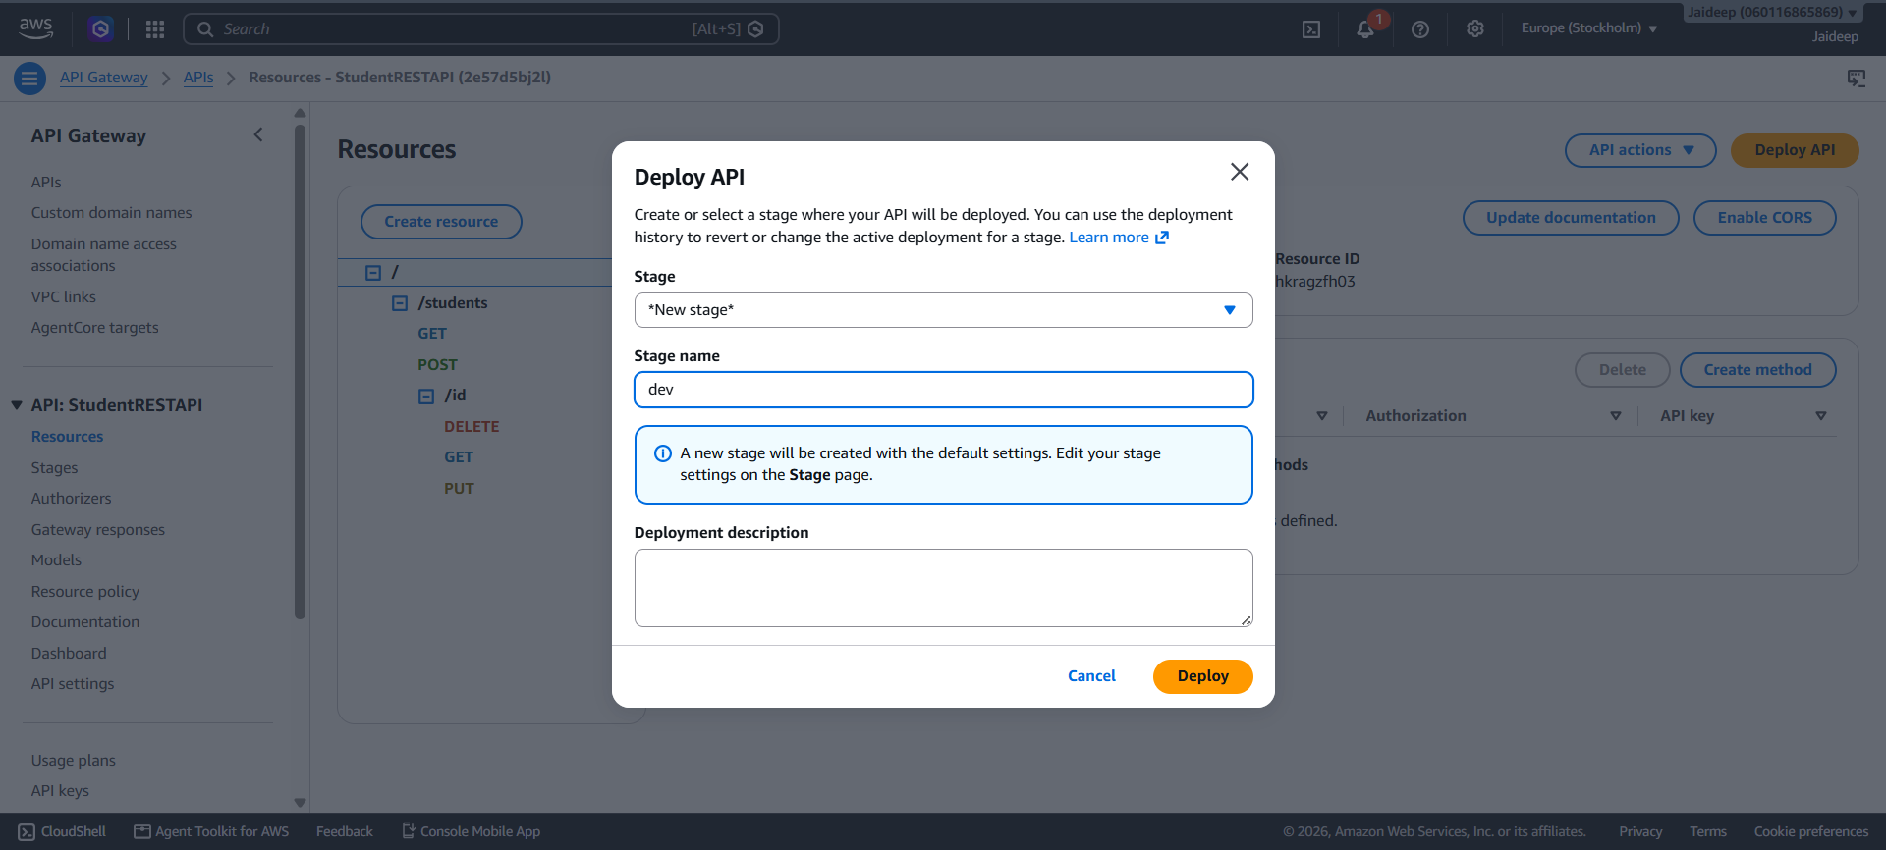
- Copy the generated Invoke URL.
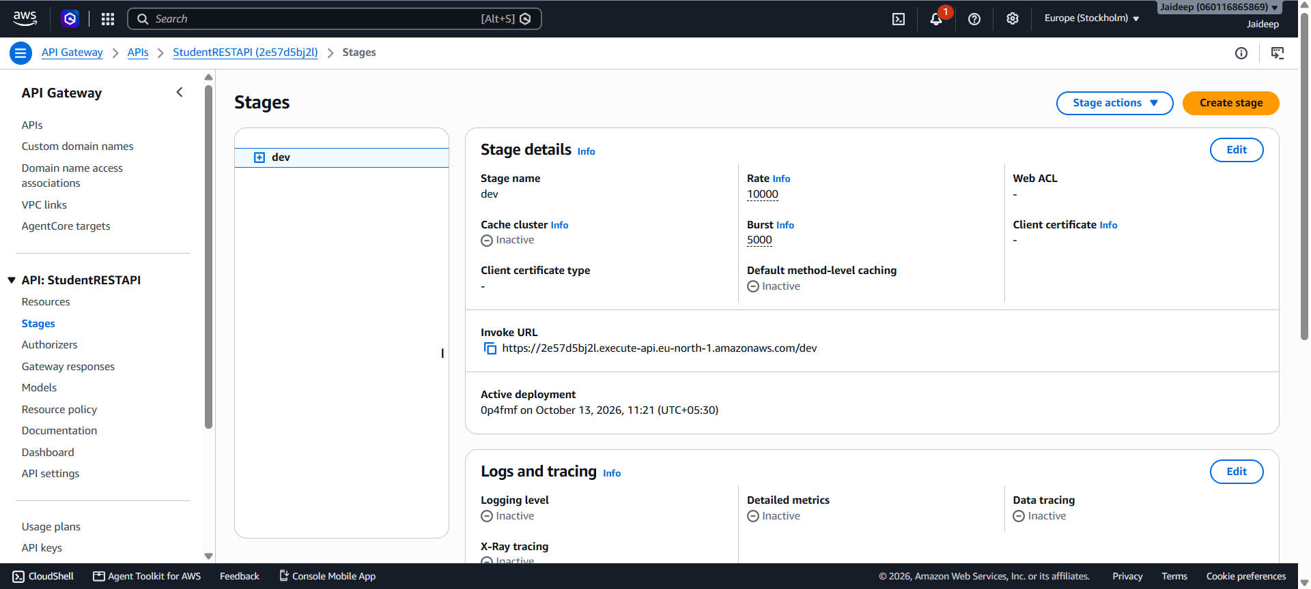
The API base URL will look similar to:
https://2e57d5bj2l.execute-api.eu-north-1.amazonaws.com/dev
The actual URL will be provided by AWS after deployment.
Step 7: Test the RESTful API
Use Thunderclient Extension available in Visual Studio Code, to test the endpoints.
A. Retrieve all students
GET /students
Expected response:

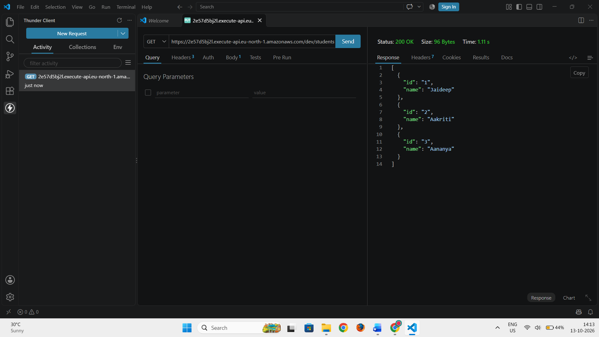
B. Retrieve a student by ID
GET /students/2
Expected response:

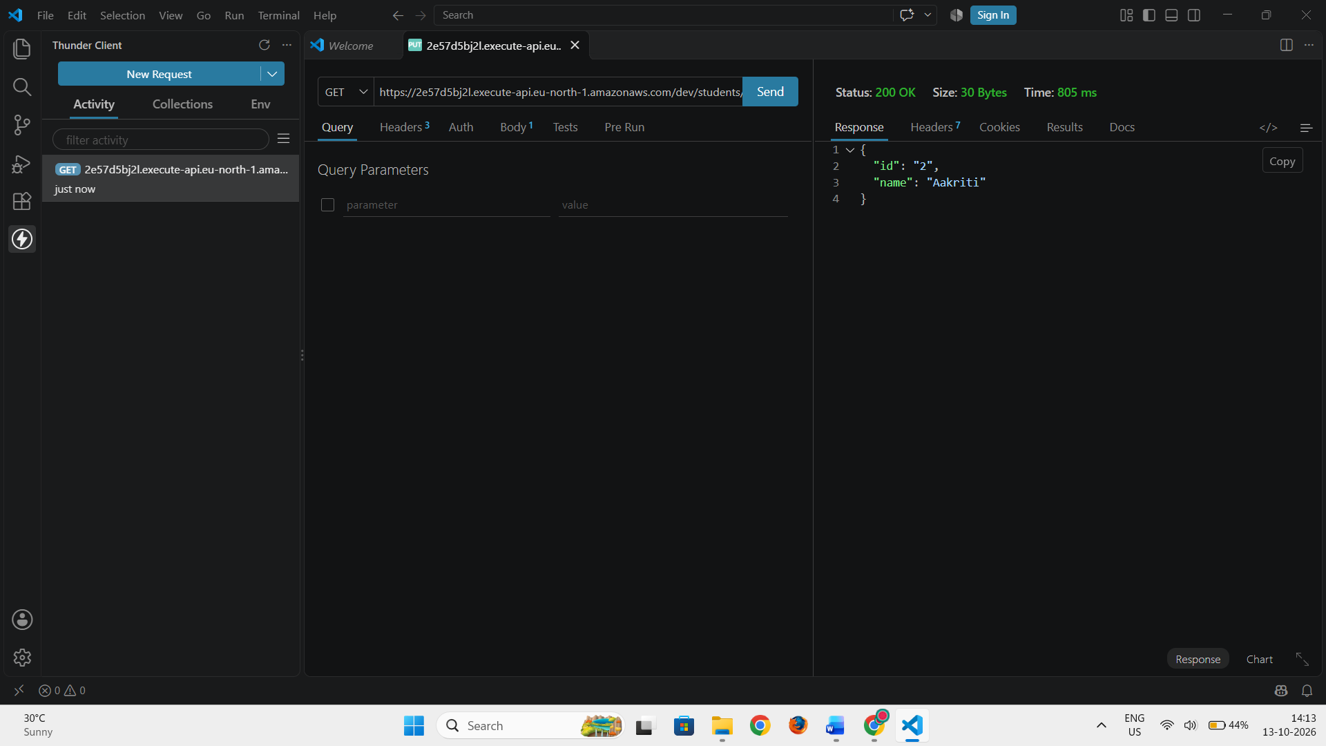
C. Add a new student
POST /students
Content-Type: application/json

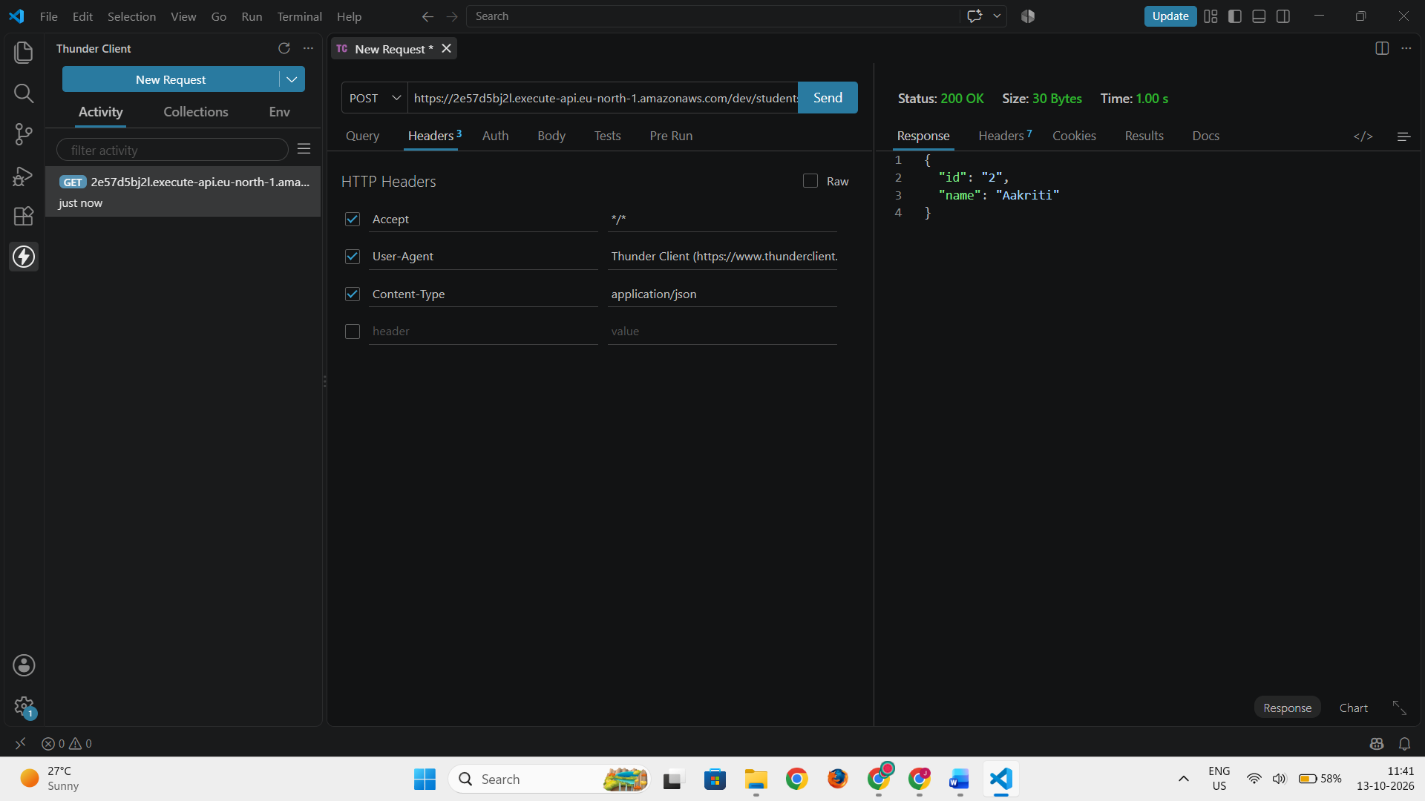
Request body:
{
"id": "4",
"name": "Vanya"
}
Expected response:

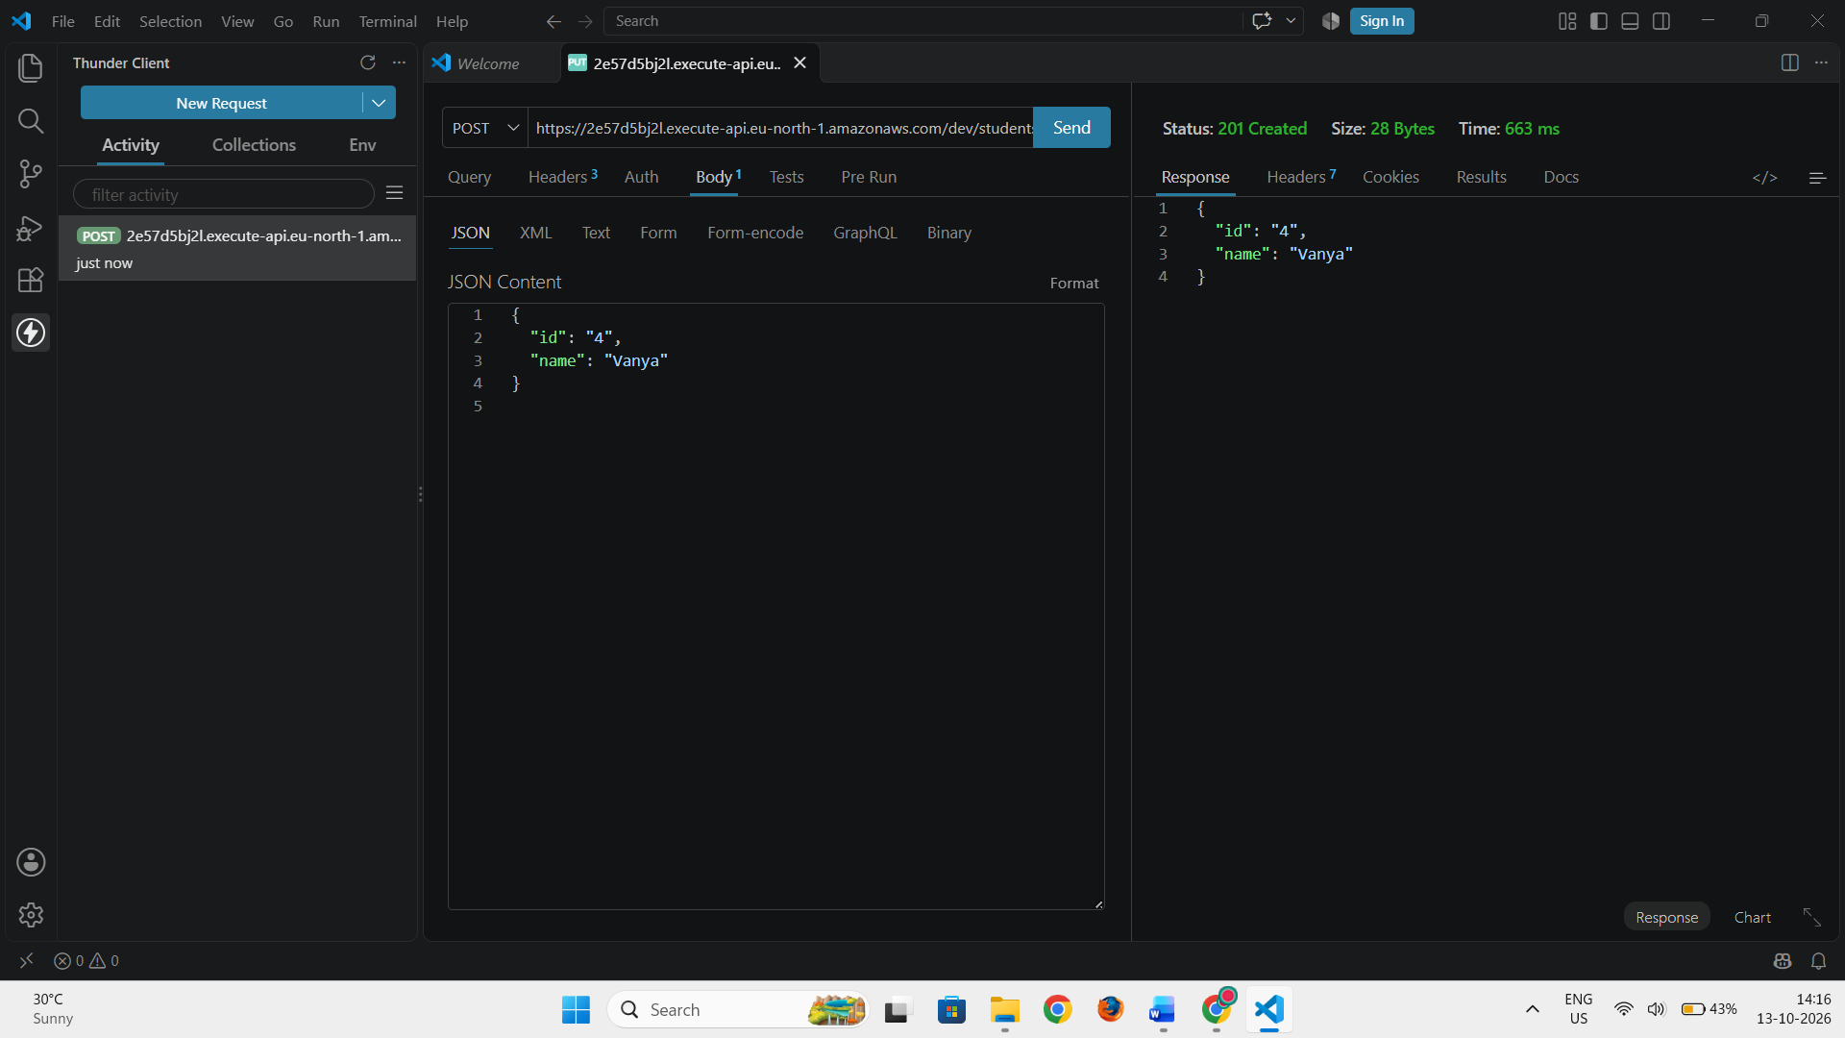
D. Update a student
PUT /students/1
Content-Type: application/json
Request body:
{
"name": "Jaideep Ahuja"
}
Expected response:

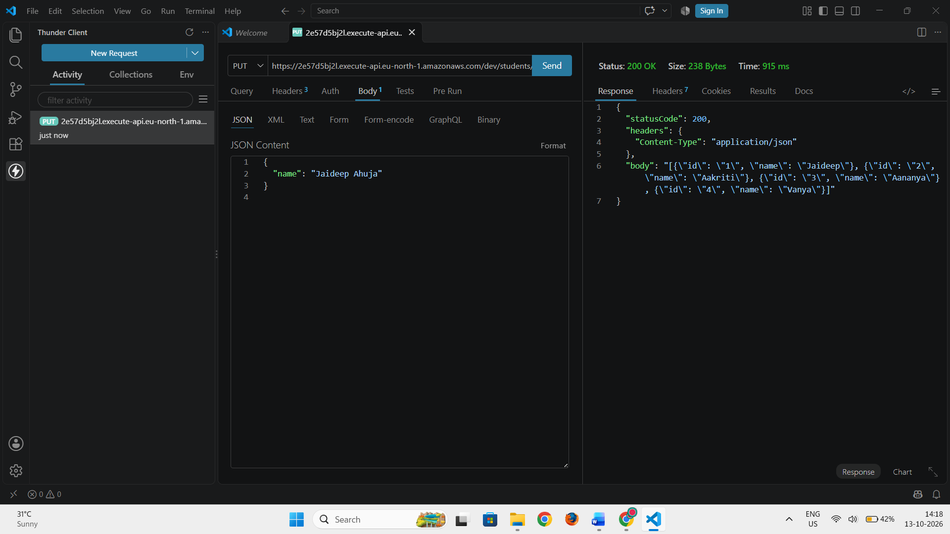
E. Delete a student
DELETE /students/1
Expected response:

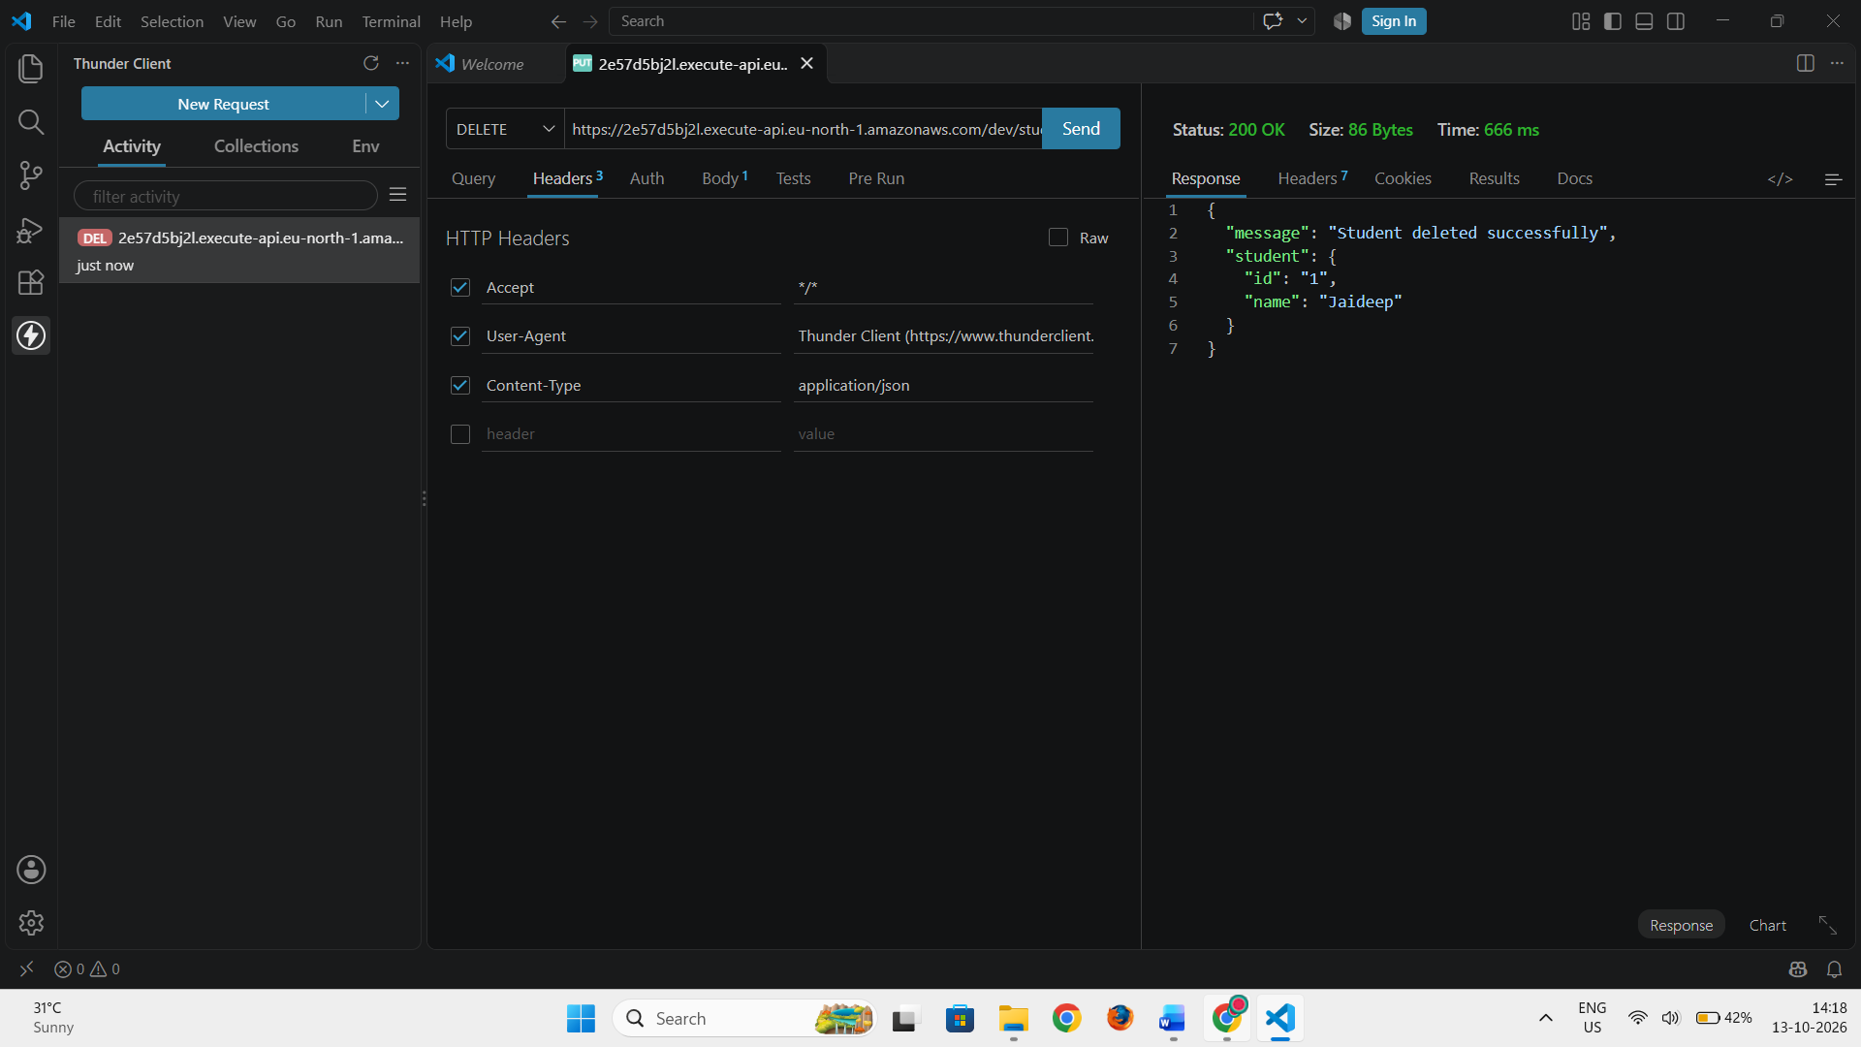
For each request, use the complete deployed URL, including the stage and resource path.
5. Expected Output
The API should perform the following operations successfully:
- Retrieve all student records.
- Retrieve a specific student using its ID.
- Create a new student record.
- Update an existing student record.
- Delete a student record.
- Return suitable HTTP status codes for successful and unsuccessful requests.
6. Result
Thus, a RESTful API was created and deployed using AWS Lambda and Amazon API Gateway. The API demonstrated CRUD operations using HTTP methods and returned responses in JSON format.

